Making Oceanic Information Accessible with Traditional Weather Applications

Sponsored Capstone Proposal

Holli Meyers

University of Washington

Information Management Practicum

Sponsored by Dr. Steven Gustafson

**Introduction**

1. **Information Problem**

The effects of climate change are to only increase. Coupled with the impacts of other human caused issues, our environment is to continue facing extreme and variable patterns that will be life altering. Thus, it’s important the public has easily accessible access to the real-time data that’s gathered globally to stay informed and allow them to plan accordingly to their current or sought out location.

Real-time environmental data is collected from a variety of different sources and locations, only some of which can actually be easily found and understood by the general public. Yet, none provide a consolidated overview of the information. This is especially true for oceanic data, which never seems to be included in weather applications. Navigating between fragmented data sources can be difficult for the average user. It requires time and patience finding sites that not only hold the correct information they seek in relation to the desired location, but also an intuitive format that makes sense and doesn’t require special downloads or software.

1. **Objective**

The project aims to design and implement a centralized web application that integrates real-time atmospheric and other weather-related information with oceanic data. To accommodate the fragmented data across government agencies, universities, research institutions, and other organizations, the platform will use schema mapping to draw data from its various structured information sources. Consequently, presenting the information systems into a unified, accessible format with features that allow users to quickly and easily, access an enhanced weather overview for their desired area.

**Research**

1. **Current Applications**

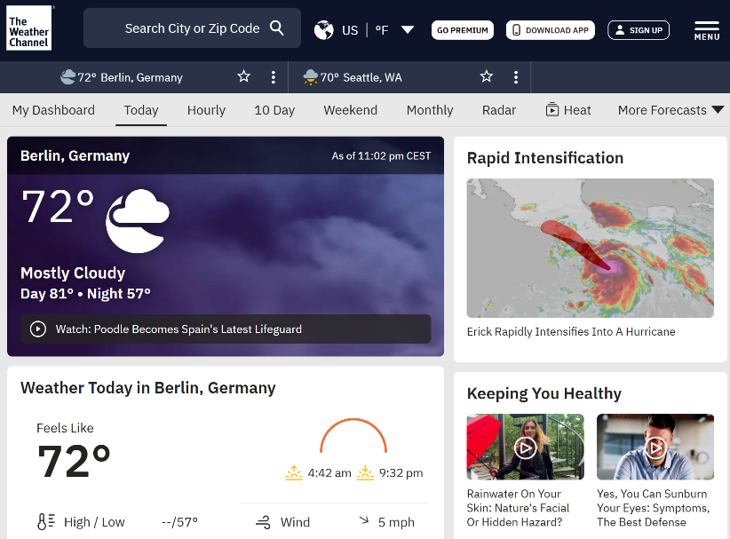The Weather Channel provides hourly, 5-day, and 10-day atmospheric forecasts. With more specialized readings of flu risk predictions from the CDC like influenza, allergy tracking of pollen density in the air, and air quality assessments of pollutions related to ozone, carbon monoxide, nitrogen dioxide, particulate matter less than 10 microns, particulate matter less than 2.5 microns, and sulfur dioxide. The Weather Channel also offers a radar map to visualize rain, snow, and fog, and a search feature to find locations globally by city (“*Weather Forecast and Conditions,*” 2025).

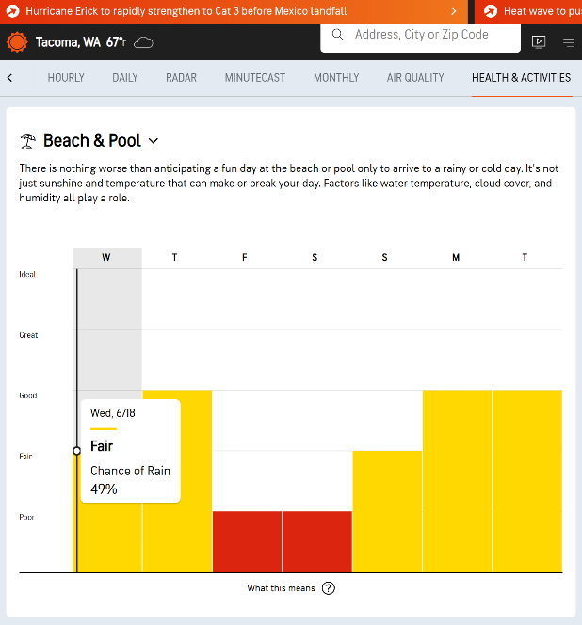 AccuWeather provides similar information plus a health and activity feature, a global severe weather map, and a few live coverage weather notifications on the top of the site’s navigation bar. The health and activity feature allows you to view a bar graph of how the weather will impact certain health conditions like arthritis, migraines, asthma, and sinus pressure. As well as, monitoring pest levels like mosquitos, garden care like mowing and composting, and other outdoor activities like fishing and pool days which give readings of cloud cover, rain, UV index, and wind (“*Beach & Pool,*” 2025).

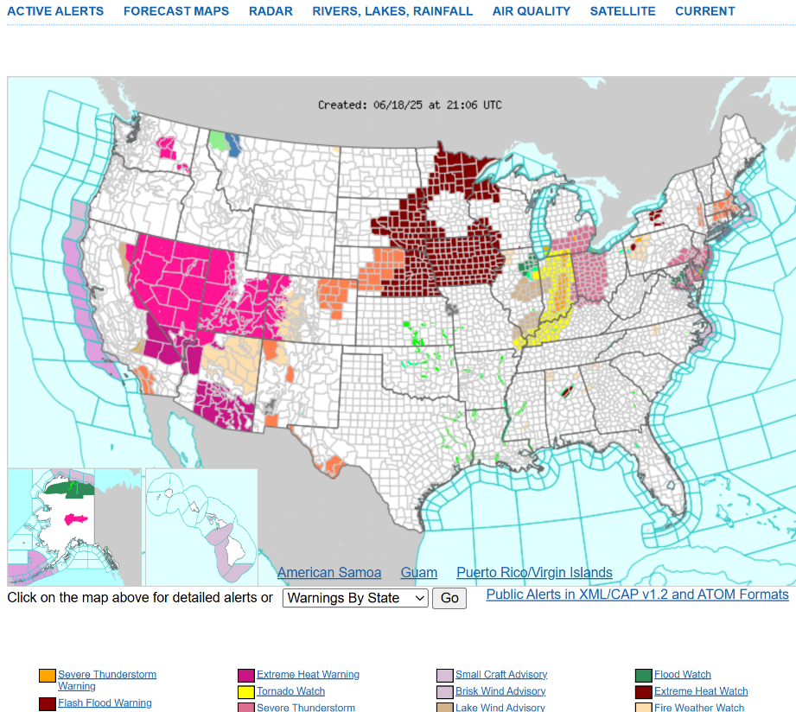 The National Oceanic and Atmospheric Administration (NOAA) has a National Weather Service site that is more simplified but less intuitive than the other applications. It offers a U.S. image loop radar map of tornados, severe thunderstorms, flash floods, special marine, and snow squall across the country. Additionally, it includes a static U.S. map of 30 weather warnings and advisories that could be showcased via different colors on the map (“*National Weather Service,*” 2025).

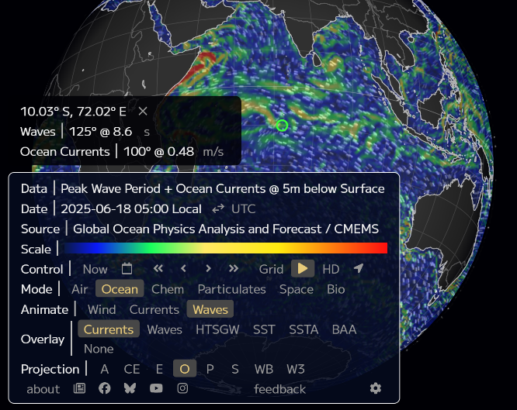Web application Earth, provides a non-traditional layout. The site seems more intuitive given its clean user interface which lacks any navigation bar or featured news articles seen in the other popular sites provided. However, it may be less legible for the general public who aren’t familiar with certain data points like what the speed of an ocean current is and what dictates it as normal or not. While Earth allows users to navigate to different areas, it doesn’t provide a location search feature to ensure an accurate pinpoint of an area (“*Earth,*” 2025).

Lastly, NOAA offers another site that compiles global information gathered through buoy stations. While it provides all the necessary information needed on oceanic data in a simplified, intuitive format, it only allows for station searches and not nearest city locations. Also, not every buoy station collects the same information. Some may gather only water temperature, while others may only gather 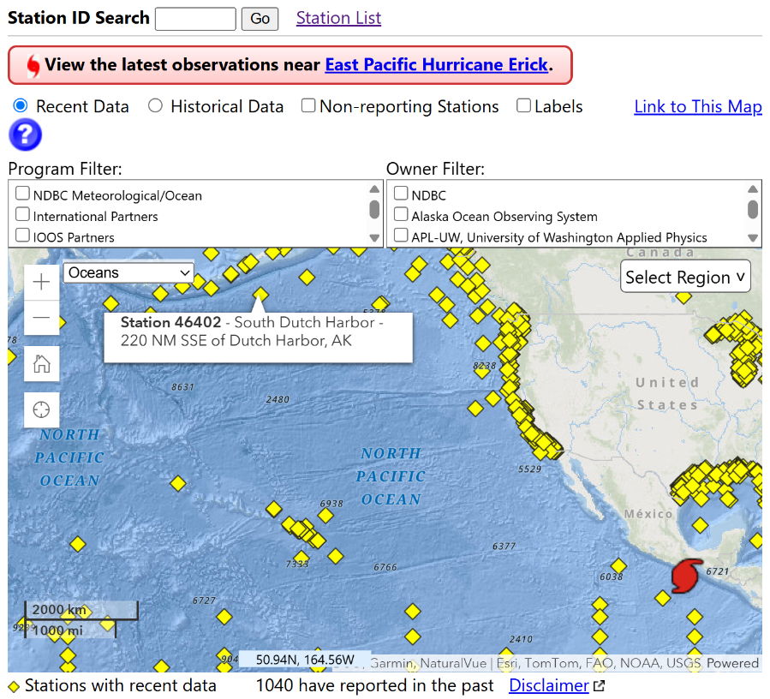water pressure and wave height, and rarely do stations also provide atmospheric readings. Due to the variation, users have to navigate to multiple stations and sites to gather the necessary information (“*National Data Buoy Center,*” 2025).

1. **Planned Methods**

|  |  |
| --- | --- |
| Step 1. Traditional Weather Application | |
| June 22 – June 28  1 Week | Select one structured weather source.  Plan and design how to create weather application with information. |
| Step 2. Back-End Development | |
| June 29 – July 12  2 Weeks | Build the back-end application using Jupyter Notebook.  Set up a Python environment (.venv).  Write Python functions that send requests to APIs of selected sources.  Integrate API responses by parsing JSON or XML.  Use local CSV, SQLite, or Pandas data frame to temporarily store data.  Write functions to handle API request errors and timeouts.  Integrate an API endpoint.  Use an APScheduler or cron to automate periodic API calls.  Test and verify functionality. |
| Step 3. Front-End Development | |
| July 13 – July 26  2 Weeks | Build the front-end application using Jupyter Notebook.  Incorporate traditional weather application interface.  Write functions to visualize information using Plotly, Matplotlib, or Seaborn.  Integrate an API request for backend communication.  Add weather visualizations to application.  Test and verify functionality. |
| Step 4. Ocean Integration | |
| July 27 – Aug 2  1 Week | Select two or more structured oceanic sources.  Plan and design how to integrate ocean information. |
| Step 5. Revise Code | |
| Aug 3 – Aug 16  2 Weeks | Integrate ocean data into application.  Improve current weather visualizations with ocean information.  Test and verify functionality. |
| Step 6. Submission Prep | |
| Aug 17 – Aug 22  1 Week | Document application by setting up a GitHub repository and add code.  Submit project. |

1. **Deliverable**

The project will result in an interactive web application. The application will present real-time oceanic and traditional weather information in a user-friendly interface. It’s aimed to contain location search features, tables, time graphs, and filtering options to toggle variables on or off. In addition, metadata will be provided alongside each data stream to ensure transparency and information credibility.

**References**

*Weather Forecast and Conditions.* (n.d.).The Weather Channel. Retrieved June 18,

2025, from https://weather.com/weather/today/l/2355888e52076fe39a2616d1423d554c7664

7d9c2f261e5b583918435bf6c42b

*Beach & Pool.* (n.d.) AccuWeather. Retrieved June 18, 2025, from https://www.accuweather.com/en

/us/tacoma/98402/sun-sand-weather/331423

*National Weather Service.* (n.d.). National Oceanic and Atmospheric Administration. Retrieved June 18,

2025, from https://www.weather.gov/

*Earth.* (n.d.). Earth. Retrieved June 18, 2025, from https://earth.nullschool.net/#current/ocean/primary

/waves/overlay=currents/orthographic=67.18,-20.43,312/loc=72.025,-10.035

*National Data Buoy Center.* (n.d.). National Oceanic and Atmospheric Administration. Retrieved June 18,

2025, from https://www.ndbc.noaa.gov/